**ARYAMAN MISHRA**

**19BCE1027**

clc

clear all

format compact

syms p(n) z pZT

assume(n>=0 & in(n,'integer'))

a=input('Enter the coefficient of p_n+2:')

b=input('Enter the coefficient of p_n+1:')

c=input('Enter the coefficient of p_n:')

G=input('Enter the RHS function:') %non homogeneous part

f=a*p(n+2)+b*p(n+1)+c*p(n)-G

fZT = ztrans(f,n,z)

fZT = subs(fZT,ztrans(p(n),n,z),pZT)

pZT = solve(fZT,pZT)

pSol = iztrans(pZT,z,n)

pSol = simplify(pSol)

a=input('Enter the value of p_0:');

b=input('Enter the value of p_1:');

disp('Solution of the difference equation is given by:')

pSol= subs(pSol,[p(0) p(1)],[a b])

nValues = 1:10;

pSolValues = subs(pSol,n,nValues);

pSolValues = double(pSolValues);

pSolValues = real(pSolValues);

stem(nValues,pSolValues)

grid on

C:\Users\aryam\Desktop\Winter Sem 2021-22\Applications of Differential Equations Lab\19-5-21\MicrosoftTeams-image.png

Enter the coefficient of p_n+2:1

a =

1

Enter the coefficient of p_n+1:-5

b =

-5

Enter the coefficient of p_n:6

c =

6

Enter the RHS function:36

G =

36

f =

p(n + 2) - 5*p(n + 1) + 6*p(n) - 36

fZT =

5*z*p(0) - 5*z*ztrans(p(n), n, z) - (36*z)/(z - 1) - z*p(1) + z^2*ztrans(p(n), n, z) - z^2*p(0) + 6*ztrans(p(n), n, z)

fZT =

6*pZT - (36*z)/(z - 1) + 5*z*p(0) - z*p(1) - 5*pZT*z - z^2*p(0) + pZT*z^2

pZT =

((36*z)/(z - 1) - 5*z*p(0) + z*p(1) + z^2*p(0))/(z^2 - 5*z + 6)

pSol =

(3^n/3 - kroneckerDelta(n, 0)/3)*(3*p(1) - 6*p(0) + 54) - (2^n/2 - kroneckerDelta(n, 0)/2)*(2*p(1) - 6*p(0) + 72) + p(0)*kroneckerDelta(n, 0) - 18*kroneckerDelta(n, 0) + 18

pSol =

3*2^n*p(0) - 2^n*p(1) - 2*3^n*p(0) + 3^n*p(1) - 36*2^n + 18*3^n + 18

Enter the value of p_0:0

Enter the value of p_1:0

Solution of the difference equation is given by:

pSol =

18*3^n - 36*2^n + 18

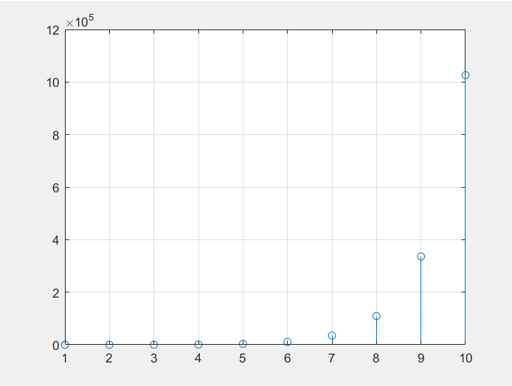

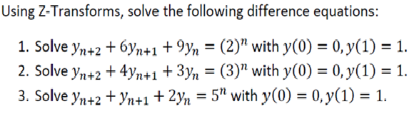

1. Enter the coefficient of p_n+2:1

a =

1

Enter the coefficient of p_n+1:6

b =

6

Enter the coefficient of p_n:9

c =

9

Enter the RHS function:2^n

G =

2^n

f =

6*p(n + 1) + p(n + 2) + 9*p(n) - 2^n

fZT =

6*z*ztrans(p(n), n, z) - z/(z - 2) - 6*z*p(0) - z*p(1) + z^2*ztrans(p(n), n, z) - z^2*p(0) + 9*ztrans(p(n), n, z)

fZT =

9*pZT - z/(z - 2) - 6*z*p(0) - z*p(1) + 6*pZT*z - z^2*p(0) + pZT*z^2

pZT =

(z/(z - 2) + 6*z*p(0) + z*p(1) + z^2*p(0))/(z^2 + 6*z + 9)

pSol =

p(0)*kroneckerDelta(n, 0) + 2^n/25 - kroneckerDelta(n, 0)/25 - (kroneckerDelta(n, 0)/9 + ((-3)^n*(n - 1))/9)*(9*p(0) + 3*p(1) - 3/5) - ((-3)^n/3 - kroneckerDelta(n, 0)/3)*(p(1) - 2/25)

pSol =

((-3)^n*n)/15 + (-3)^n*p(0) + 2^n/25 - (-3)^n/25 - (-3)^n*n*p(0) - ((-3)^n*n*p(1))/3

Enter the value of p_0:0

Enter the value of p_1:1

Solution of the difference equation is given by:

pSol =

2^n/25 - (4*(-3)^n*n)/15 - (-3)^n/25

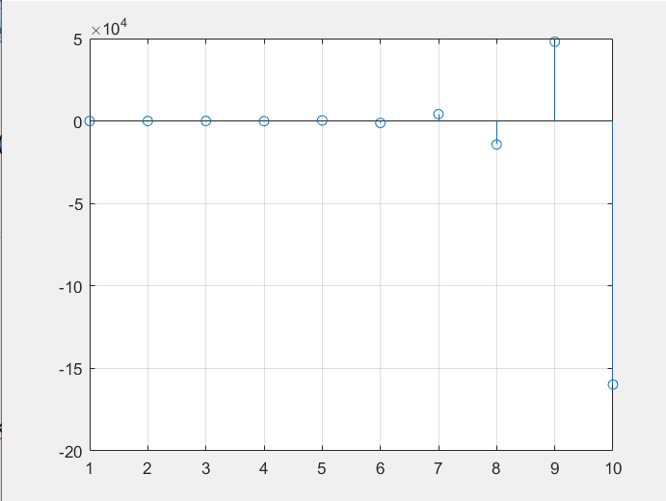

2. Enter the coefficient of p_n+2:1

a =

1

Enter the coefficient of p_n+1:4

b =

4

Enter the coefficient of p_n:3

c =

3

Enter the RHS function:3^n

G =

3^n

f =

4*p(n + 1) + p(n + 2) + 3*p(n) - 3^n

fZT =

4*z*ztrans(p(n), n, z) - z/(z - 3) - 4*z*p(0) - z*p(1) + z^2*ztrans(p(n), n, z) - z^2*p(0) + 3*ztrans(p(n), n, z)

fZT =

3*pZT - z/(z - 3) - 4*z*p(0) - z*p(1) + 4*pZT*z - z^2*p(0) + pZT*z^2

pZT =

(z/(z - 3) + 4*z*p(0) + z*p(1) + z^2*p(0))/(z^2 + 4*z + 3)

pSol =

p(0)*kroneckerDelta(n, 0) - ((-3)^n/3 - kroneckerDelta(n, 0)/3)*((3*p(0))/2 + (3*p(1))/2 - 1/4) + ((-1)^n - kroneckerDelta(n, 0))*((3*p(0))/2 + p(1)/2 - 1/8) + 3^n/24 - kroneckerDelta(n, 0)/24

pSol =

(3*(-1)^n*p(0))/2 + ((-1)^n*p(1))/2 - ((-3)^n*p(0))/2 - ((-3)^n*p(1))/2 - (-1)^n/8 + (-3)^n/12 + 3^n/24

Enter the value of p_0:0

Enter the value of p_1:1

Solution of the difference equation is given by:

pSol =

(3*(-1)^n)/8 - (5*(-3)^n)/12 + 3^n/24

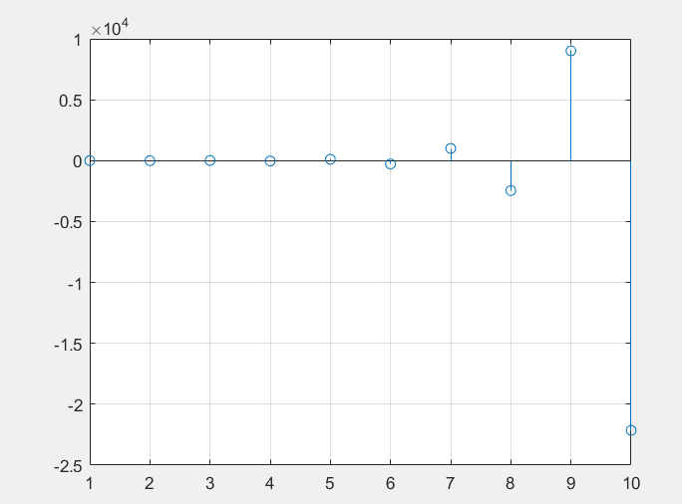

3) Enter the coefficient of p_n+2:1

a =

1

Enter the coefficient of p_n+1:1

b =

1

Enter the coefficient of p_n:2

c =

2

Enter the RHS function:5^n

G =

5^n

f =

p(n + 1) + p(n + 2) + 2*p(n) - 5^n

fZT =

z*ztrans(p(n), n, z) - z/(z - 5) - z*p(0) - z*p(1) + z^2*ztrans(p(n), n, z) - z^2*p(0) + 2*ztrans(p(n), n, z)

fZT =

2*pZT - z/(z - 5) - z*p(0) - z*p(1) + pZT*z - z^2*p(0) + pZT*z^2

pZT =

(z/(z - 5) + z*p(0) + z*p(1) + z^2*p(0))/(z^2 + z + 2)

pSol =

p(0)*kroneckerDelta(n, 0) - (p(0) - 1/32)*kroneckerDelta(n, 0) + 5^n/32 - kroneckerDelta(n, 0)/32 - ((-1)^n*7^(1/2)*(1/2 - (7^(1/2)*1i)/2)^(n - 1)*(p(0) + 2*p(1) - 11/32)*2i)/7 + ((-1)^n*7^(1/2)*((7^(1/2)*1i)/2 + 1/2)^(n - 1)*(p(0) + 2*p(1) - 11/32)*2i)/7 - (2*(-1)^n*2^n*cos(n*acos(2^(1/2)/4))*(p(1) - 5/32))/2^(n/2)

pSol =

p(0)*kroneckerDelta(n, 0) - (p(0) - 1/32)*kroneckerDelta(n, 0) + 5^n/32 - kroneckerDelta(n, 0)/32 - ((-1)^n*7^(1/2)*(1/2 - (7^(1/2)*1i)/2)^(n - 1)*(p(0) + 2*p(1) - 11/32)*2i)/7 + ((-1)^n*7^(1/2)*((7^(1/2)*1i)/2 + 1/2)^(n - 1)*(p(0) + 2*p(1) - 11/32)*2i)/7 - (2*(-1)^n*2^n*cos(n*acos(2^(1/2)/4))*(p(1) - 5/32))/2^(n/2)

Enter the value of p_0:0

Enter the value of p_1:1

Solution of the difference equation is given by:

pSol =

5^n/32 - ((-1)^n*7^(1/2)*(1/2 - (7^(1/2)*1i)/2)^(n - 1)*53i)/112 + ((-1)^n*7^(1/2)*((7^(1/2)*1i)/2 + 1/2)^(n - 1)*53i)/112 - (27*(-1)^n*2^n*cos(n*acos(2^(1/2)/4)))/(16*2^(n/2))

